**ST. LUKE’S EPISCOPAL CHURCH**

**Shawnee, Kansas**

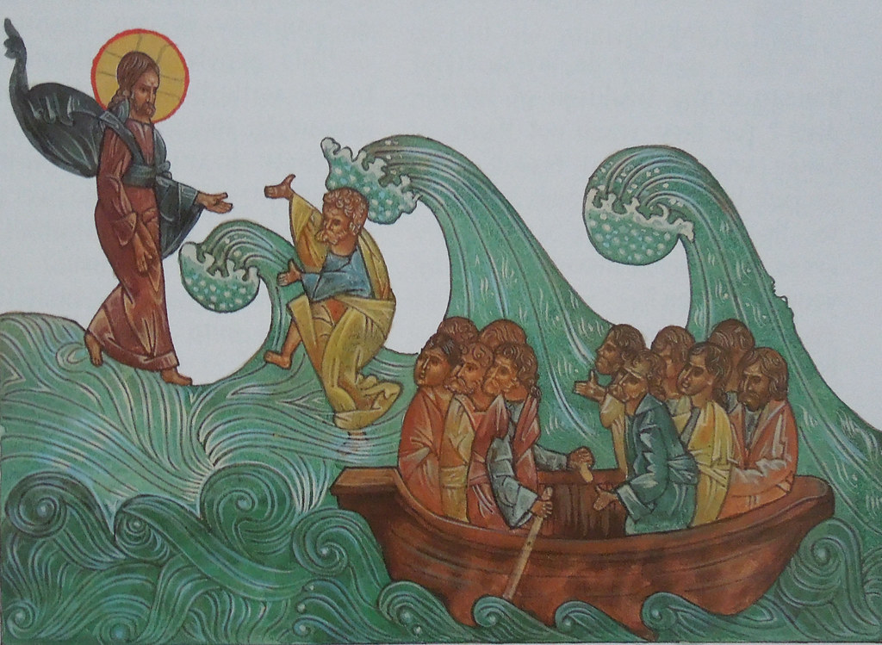

[This Photo](https://www.flickr.com/photos/frted/6995551815) by Unknown Author is licensed under [CC BY-SA](https://creativecommons.org/licenses/by-sa/3.0/)

**Holy Eucharist Rite II**

**The Eleventh Sunday after Pentecost**

**Proper 14**

August 13, 2023 10:30 a.m.

*People standing as able.*

**The Opening Hymn** *There’s a Wideness in God’s Mercy*

*The Hymnal 1982 #470*

*All standing, the Celebrant says*

## Opening Acclamation

*Celebrant* Blessed be God: Father, Son and Holy Spirit.

*People* ***And blessed be his kingdom, now and for ever. Amen.***

## Collect of Purity

Almighty God, to you all hearts are open, all desires known, and from you no secrets are hid: Cleanse the thoughts of our hearts by the inspiration of your Holy Spirit, that we may perfectly love you, and worthily magnify your holy Name; through Christ our Lord. ***Amen.***

**Song of Praise** *The Hymnal 1982 #S279*

*Sung all together*

## Collect of the Day

*Celebrant* The Lord be with you.

*People* ***And also with you.***

*Celebrant* Let us pray.

Grant to us, Lord, we pray, the spirit to think and do always those things that are right, that we, who cannot exist without you, may by you be enabled to live according to your will; through Jesus Christ our Lord, who lives and reigns with you and the Holy Spirit, one God, for ever and ever. ***Amen.***

*Please be seated.*

**The Lessons**

### The Old Testament Genesis 37:1-4, 12-28

Jacob settled in the land where his father had lived as an alien, the land of Canaan. This is the story of the family of Jacob.

Joseph, being seventeen years old, was shepherding the flock with his brothers; he was a helper to the sons of Bilhah and Zilpah, his father’s wives; and Joseph brought a bad report of them to their father. Now Israel loved Joseph more than any other of his children, because he was the son of his old age; and he had made him a long robe with sleeves. But when his brothers saw that their father loved him more than all his brothers, they hated him, and could not speak peaceably to him.

Now his brothers went to pasture their father’s flock near Shechem. And Israel said to Joseph, “Are not your brothers pasturing the flock at Shechem? Come, I will send you to them.” He answered, “Here I am.” So he said to him, “Go now, see if it is well with your brothers and with the flock; and bring word back to me.” So he sent him from the valley of Hebron.

He came to Shechem, and a man found him wandering in the fields; the man asked him, “What are you seeking?” “I am seeking my brothers,” he said; “tell me, please, where they are pasturing the flock.” The man said, “They have gone away, for I heard them say, ‘Let us go to Dothan.’” So Joseph went after his brothers, and found them at Dothan. They saw him from a distance, and before he came near to them, they conspired to kill him. They said to one another, “Here comes this dreamer. Come now, let us kill him and throw him into one of the pits; then we shall say that a wild animal has devoured him, and we shall see what will become of his dreams.” But when Reuben heard it, he delivered him out of their hands, saying, “Let us not take his life.” Reuben said to them, “Shed no blood; throw him into this pit here in the wilderness, but lay no hand on him” —that he might rescue him out of their hand and restore him to his father. So when Joseph came to his brothers, they stripped him of his robe, the long robe with sleeves that he wore; and they took him and threw him into a pit. The pit was empty; there was no water in it.

Then they sat down to eat; and looking up they saw a caravan of Ishmaelites coming from Gilead, with their camels carrying gum, balm, and resin, on their way to carry it down to Egypt. Then Judah said to his brothers, “What profit is it if we kill our brother and conceal his blood? Come, let us sell him to the Ishmaelites, and not lay our hands on him, for he is our brother, our own flesh.” And his brothers agreed. When some Midianite traders passed by, they drew Joseph up, lifting him out of the pit, and sold him to the Ishmaelites for twenty pieces of silver. And they took Joseph to Egypt..

*Reader* The Word of the Lord.

*People* ***Thanks be to God.***

### The Psalm Psalm 105, 1-6, 16-22, 45b

*Confitemini Domino*

**1 Give thanks to the Lord and call upon his Name; *  
make known his deeds among the peoples.**

**2 Sing to him, sing praises to him, *  
and speak of all his marvelous works.**

**3 Glory in his holy Name; *  
let the hearts of those who seek the Lord rejoice.**

**4 Search for the Lord and his strength; *  
continually seek his face.**

**5 Remember the marvels he has done, *  
his wonders and the judgments of his mouth,**

**6 O offspring of Abraham his servant, *  
O children of Jacob his chosen.**

**16 Then he called for a famine in the land *  
and destroyed the supply of bread.**

**17 He sent a man before them, *  
Joseph, who was sold as a slave.**

**18 They bruised his feet in fetters; *  
his neck they put in an iron collar.**

**19 Until his prediction came to pass, *  
the word of the Lord tested him.**

**20 The king sent and released him; *  
the ruler of the peoples set him free.**

**21 He set him as a master over his household,  
as a ruler over all his possessions,**

**22 To instruct his princes according to his will  
and to teach his elders wisdom.**

**45 Hallelujah!**

*A period of silence is kept.*

### Special Musical Performance featuring Isaac Fields *If That Isn’t Love*

### The Epistle Romans 10:5-15

Moses writes concerning the righteousness that comes from the law, that “the person who does these things will live by them.” But the righteousness that comes from faith says, “Do not say in your heart, ‘Who will ascend into heaven?’” (that is, to bring Christ down) “or ‘Who will descend into the abyss?’” (that is, to bring Christ up from the dead). But what does it say?

“The word is near you,  
on your lips and in your heart”

(that is, the word of faith that we proclaim); because if you confess with your lips that Jesus is Lord and believe in your heart that God raised him from the dead, you will be saved. For one believes with the heart and so is justified, and one confesses with the mouth and so is saved. The scripture says, “No one who believes in him will be put to shame.” For there is no distinction between Jew and Greek; the same Lord is Lord of all and is generous to all who call on him. For, “Everyone who calls on the name of the Lord shall be saved.”

But how are they to call on one in whom they have not believed? And how are they to believe in one of whom they have never heard? And how are they to hear without someone to proclaim him? And how are they to proclaim him unless they are sent? As it is written, “How beautiful are the feet of those who bring good news!”

*Reader* The Word of the Lord.

*People* ***Thanks be to God.***

*Please stand as able.*

**Gospel Anthem** *In Your Mercy, Lord, You Called Me*

*The Hymnal 1982 #706*

## The Gospel Matthew 14:22-33

*All stand as able.*

*Celebrant* The Holy Gospel of our Lord Jesus Christ according to Matthew.

*People* ***Glory to you, Lord Christ.***

Jesus made the disciples get into the boat and go on ahead to the other side, while he dismissed the crowds. And after he had dismissed the crowds, he went up the mountain by himself to pray. When evening came, he was there alone, but by this time the boat, battered by the waves, was far from the land, for the wind was against them. And early in the morning he came walking toward them on the sea. But when the disciples saw him walking on the sea, they were terrified, saying, “It is a ghost!” And they cried out in fear. But immediately Jesus spoke to them and said, “Take heart, it is I; do not be afraid.”

Peter answered him, “Lord, if it is you, command me to come to you on the water.” He said, “Come.” So Peter got out of the boat, started walking on the water, and came toward Jesus. But when he noticed the strong wind, he became frightened, and beginning to sink, he cried out, “Lord, save me!” Jesus immediately reached out his hand and caught him, saying to him, “You of little faith, why did you doubt?” When they got into the boat, the wind ceased. And those in the boat worshiped him, saying, “Truly you are the Son of God.”

*Celebrant* The Gospel of the Lord.

*People* ***Praise to you, Lord Christ.***

*Please be seated.*

**The Sermon The Reverend Jonathan Brice**

## The Nicene Creed

*All stand and say together.*

**We believe in one God,**

**the Father, the Almighty,**

**maker of heaven and earth,**

**of all that is, seen and unseen.**

**We believe in one Lord, Jesus Christ,**

**the only Son of God,**

**eternally begotten of the Father,**

**God from God, Light from Light,**

**true God from true God,**

**begotten, not made,**

**of one Being with the Father.**

**Through him all things were made.**

**For us and our salvation**

**he came down from heaven:**

**by the power of the Holy Spirit**

**he became incarnate from the Virgin Mary,**

**and was made man.**

**For our sake he was crucified under Pontius Pilate;**

**he suffered death and was buried.**

**On the third day he rose again**

**in accordance with the Scriptures;**

**he ascended into heaven**

**and is seated at the right hand of the Father.**

**He will come again in glory to judge the living and the dead,**

**And his kingdom will have no end.**

**We believe in the Holy Spirit, the Lord, the giver of life,**

**who proceeds from the Father and the Son.**

**With the Father and the Son he is worshiped and glorified.**

**He has spoken through the Prophets.**

**We believe in one holy catholic and apostolic Church.**

**We acknowledge one baptism for the forgiveness of sins.**

**We look for the resurrection of the dead,**

**and the life of the world to come. Amen**

*Please stand or kneel as able.*

## [http://www.abstract-soul.com/resources/prayer114_100185915_std.jpg](http://www.abstract-soul.com/the-prayer-of-a-failure.php)Prayers of the People

## August 13, 2023

**The Eleventh Sunday after Pentecost**

*We are the ark of the church, at times storm-tossed and frightened. Let us cry out in faith for our own needs and the needs of the world, saying:* ***Lord, save us.***

For those churches who are resisting oppression and enduring persecution in the name of the gospel, let us cry out to the Lord. ***Lord, save us.***

For the leaders of nations, communities, and households who are faced with terrible choices and whose decisions affect the lives of many, let us cry out to the Lord. ***Lord, save us.***

For those caught in addictions of mind or body, for those who feel powerless and sink ever deeper into despair, let us cry out to the Lord. ***Lord, save us.***

For those who rely on themselves, for those who struggle to trust in God’s beckoning word, for those who know fear before the actions of grace, let us cry out to the Lord. ***Lord, save us.***

For all of us who gather at this eucharistic table, weak in faith, faltering in our response to God, let us cry out to the Lord. ***Lord, save us.***

Father of all, we pray to you for Swede Holmberg and Bobbi Duran Elliot, and for all those whom we love but see no longer. Grant to them eternal rest. Let light perpetual shine upon them. May his soul and the souls of all the departed, through the mercy of God, rest in peace.

**In the World Council of Churches Cycle of Prayer:**

Pray for the people of Burkina Faso, Chad, Mali, Mauritania, Niger

**In the Kansas Cycle of Prayer:**

Pray for St. David’s, Topeka

let us cry out to the Lord. ***Lord, save us.***

**For Those Serving in the Armed Forces:** Devon Allen; Murphy Bright; Ben Dible; Coy Goodman; Michael Green; Harvey Hayselden; Benjamin Karpinski; Alex Shaw; Jose Te’o; Collin Kelly; Macauley Garton; Frank Bednar; Grant Bednar; Henry Kniggendorf; Sean Bess; Maxwell Hayselden;

let us cry out to the Lord. ***Lord, save us.***

**For Health & Strength:**The Holmberg family; Christy Keller;Craig and Jeanette Burris; Katherine Riggins & family; Kenneth Cox & family; Viola Cleo Bradshaw; Gloria Beaty and the Beaty Family; Maxdon Fuller; Kyle Roberts; Trudy Vanderwide; Cindy Keller; Scott Forsen; Kay Allen; Jeanne and Bruce Miller; Kristy Maendele; Staci Hersh; John Birtwell and Family; Theresa Textor; Eloise and Claton Clevenger and family; Dalton Peavler;

let us cry out to the Lord. ***Lord, save us.***

**For Birthdays:** Matthew Sherman

**For Anniversaries:** Tim and Diane Rohrer

let us cry out to the Lord. ***Lord, save us.***

*O true and faithful God, you are the hope of those who cry out to you. Hear our petitions. Where there is no faith, awaken it; where there is little faith, enlarge it, that one day we may all come to acknowledge Jesus as your Son and the savior of the world. We ask this in his name, who is one with you and the Holy Spirit, God, forever and ever.* ***Amen.***

*A period of silence is kept.*

**Birthday Prayer**

Watch over your children, O Lord, as their days increase; bless and guide them wherever they may be. Strengthen them when they stand; comfort them when discouraged or sorrowful; raise them up if they fall; and in their hearts may your peace which passes understanding abide all the days of their lives; through Jesus Christ our Lord.**Amen.**

**Anniversary Prayer**

O gracious and ever living God, look mercifully upon this couple who come to you seeking your blessing on this their anniversary, continue assisting them with your grace, that with true fidelity and steadfast love they may honor and keep the promises and vows they have made; through Jesus Christ our Savior. **Amen**.

## The Confession of Sin

*Celebrant* Let us confess our sins against God and our neighbor.

*The people kneel as they are able.*

*Celebrant and People*

**Most merciful God,**

**we confess that we have sinned against you**

**in thought, word, and deed,**

**by what we have done, and by what we have left undone.**

**We have not loved you with our whole heart;**

**we have not loved our neighbors as ourselves.**

**We are truly sorry and we humbly repent.**

**For the sake of your Son Jesus Christ,**

**have mercy on us and forgive us;**

**that we may delight in your will,**

**and walk in your ways,**

**to the glory of your Name. Amen.**

*Priest*

Almighty God have mercy on you, forgive you all your sins through our Lord Jesus Christ, strengthen you in all goodness, and by the power of the Holy Spirit keep you in eternal life. ***Amen.***

## The Exchange of Peace

*All stand as able.*

*Celebrant*The peace of the Lord be always with you.

*People* ***And also with you.***

*Greet each other safely.*

## The Offertory Sentence

C*elebrant*

Ascribe to the Lord the honor due his Name; bring

offering and come into his courts. *Psalm 96:8*

**Offertory Anthem** *How Great Thou Art*

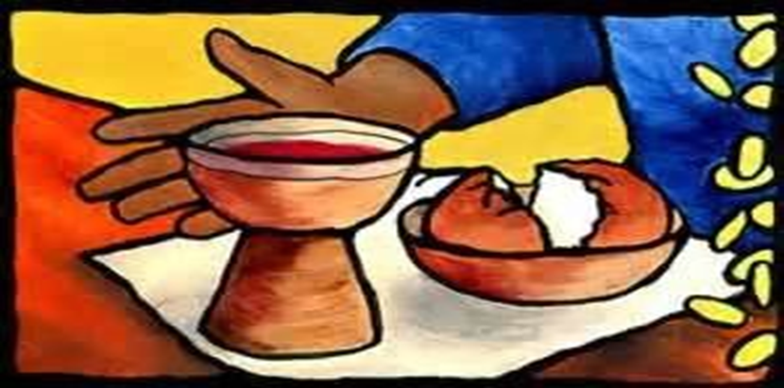

**The Presentation of Bread**

*All stand as able.*

*[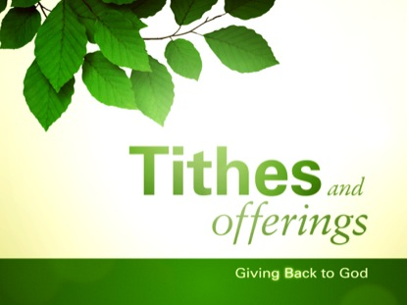](http://www.worshiphousemedia.com/motion-backgrounds/31255/Spring-Leaves-Tithes--Offerin)***Presentation of Gifts**

*Representatives of the congregation*

*bring the people’s offerings of bread and wine.*

**Doxology** *The Hymnal 1982 #380 v. 3*

*Celebrant*All things come from you O Lord.

*People****And of your own have we given you. Amen.***

**THE GREAT THANKSGIVING   Eucharistic Prayer A**

*Standing as you are able.*

*Celebrant*The Lord be with you.

*People****And also with you.***

*Celebrant*Lift up your hearts.

*People****We lift them to the Lord.***

*Celebrant*Let us give thanks to the Lord our God.

*People****It is right to give him thanks and praise.***

*Celebrant*

It is right, and a good and joyful thing, always and everywhere to give thanks to you, Father Almighty, Creator of heaven and earth.

For you are the source of light and life, you made us in your image, and called us to new life in Jesus Christ our Lord.

Therefore we praise you, joining our voices with Angels and Archangels and with all the company of heaven, who for ever sing this hymn to proclaim the glory of your Name:

*Celebrant and People The Hymnal 1982 # S-125*

*The people stand or kneel.*

*Celebrant*

Holy and gracious Father: In your infinite love you made us for yourself; and, when we had fallen into sin and become subject to evil and death, you, in your mercy, sent Jesus Christ, your only and eternal Son, to share our human nature, to live and die as one of us, to reconcile us to you, the God and Father of all.

He stretched out his arms upon the cross, and offered himself in obedience to your will, a perfect sacrifice for the whole world.

On the night he was handed over to suffering and death, our Lord Jesus Christ took bread; and when he had given thanks to you, he broke it, and gave it to his disciples, and said, “Take, eat: This is my Body, which is given for you. Do this for the remembrance of me.”

After supper he took the cup of wine; and when he had given thanks, he gave it to them, and said, “Drink this, all of you: This is my Blood of the new Covenant, which is shed for you and for many for the forgiveness of sins. Whenever you drink it, do this for the remembrance of me.”

Therefore we proclaim the mystery of faith:

*Celebrant and People*

**Christ has died.**

**Christ is risen.**

**Christ will come again.**

*Celebrant*

We celebrate the memorial of our redemption, O Father, in this sacrifice of praise and thanksgiving. Recalling his death, resurrection, and ascension, we offer you these gifts.

Sanctify them by your Holy Spirit to be for your people the Body and Blood of your Son, the holy food and drink of new and unending life in him. Sanctify us also that we may faithfully receive this holy Sacrament, and serve you in unity, constancy, and peace; and at the last day bring us with all your saints into the joy of your eternal kingdom.

All this we ask through your Son Jesus Christ. By him, and with him, and in him, in the unity of the Holy Spirit all honor and glory is yours, Almighty Father, now and for ever. ***AMEN.***

*Celebrant*

And now, as our Savior Christ has taught us, we are bold to say,

**The Lord’s Prayer**

*(All together)*

**Our Father, who art in heaven,**

**hallowed be thy Name,**

**thy kingdom come,**

**thy will be done,**

**on earth as it is in heaven.**

**Give us this day our daily bread.**

**And forgive us our trespasses,**

**as we forgive those**

**who trespass against us.**

**And lead us not into temptation,**

**but deliver us from evil.**

**For thine is the kingdom, and the power, and the glory,**

**for ever and ever. Amen.**

## The Breaking of the Bread

*A period of silence is kept.*

*Celebrant*Alleluia.Christ our Passover is sacrificed for us;

*People* ***Therefore let us keep the feast. Alleluia***

*Celebrant* The Gifts of God for the People of God. Take them in remembrance that Christ died for you, and feed on him in your hearts by faith, with thanksgiving.

*Celebrant*

The table of bread is now made ready.

It is the table of company with Jesus, and all who love him.

It is the table of sharing with the poor of the world, with whom Jesus identified himself.

It is the table of communion with the earth, in which Christ became incarnate.

So come to this table, you who have much faith, and you who would like to have more;

you who have been here often, and you who have not been for a long time;

you who have tried to follow Jesus, and you who have failed; come.

It is Christ who invites us to meet him here.

**Holy Communion**[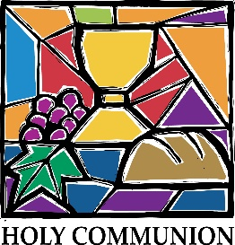](http://weewaapc.wordpress.com/2012/05/31/holy-communio)*All are welcome at the altar rail. All baptized persons are welcome to receive Holy Communion. If you are not baptized or if you prefer a blessing only, cross your arms over your chest at the altar.*

*Gluten-free wafers are available; please make your needs known to the minister.*

*The choir will receive first. Please wait until the usher releases your pew. You may stand or kneel at the altar rail. Father Jonathan will intinct the wafer in consecrated wine. If you do not desire this please make your needs known.*

**Communion Hymn** *It is Well With My Soul*

*Kneel as you are able.*

## Post-Communion Prayer

*Celebrant* Let us pray.

*Celebrant and People*

**Eternal God, heavenly Father,**

**you have graciously accepted us as living members**

**of your Son our Savior Jesus Christ,**

**and you have fed us with spiritual food**

**in the Sacrament of his Body and Blood.**

**Send us now into the world in peace,**

**and grant us strength and courage**

**to love and serve you**

**with gladness and singleness of heart;**

**through Christ our Lord. Amen.**

**The Blessing**

*Celebrant*

The peace of God, which passes all understanding , keep your hearts and minds in the knowledge and love of God, and of his Son Jesus Christ our Lord; and the blessing of God Almighty, the Father, the Son and the Holy Spirit, be among you, and remain with you always. ***Amen.***

**Blessing of the Backpacks**

*We invite all students, grad students, teachers, and all school personnel to bring their bags ups to be blessed by Father Jonathan for a safe and joyful school year.*

## Announcements

*Stand as able.*

**The Closing Hymn** *Leaning on Everlasting Arms* *(What a Fellowship)*

## The Dismissal

*Celebrant* Let us go forth in the name of Christ*.*

*People* ***Thanks be to God. Alleluia. Alleluia.***

Flowers Given:

In Loving Memory Of David Schekall by Tom and Caren Grandgenett

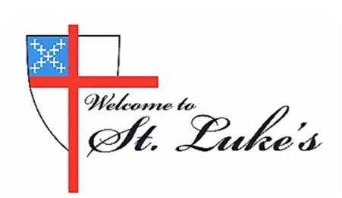

The Rev. Jonathan Brice

Associate Vicar: The Rev. Shawn Streepy

Music Director: Boyd Ahrens

Special Musical Performers: Isaac Fields and Novell Atkinson

Technical Team: Dennis Phillips, Dr. Wayne Fowler Jr.

St. Luke’s Episcopal Church  5325 Nieman Road Shawnee, KS 66203

913-631-8597      [www.stlukes.net](http://www.stlukes.net)

**Thank you for joining us today.**

Please subscribe to St. Luke’s [YouTube channel](https://www.youtube.com/channel/UCJmB4I40AEJBFalA7QErK4w) and stay in touch through our newsletters.

Music License: H 470: Words: Frederick William Faber (1814-1863). Music: Beecher, John Zundel (1815-1882), alt.. H S279 – Setting: Gerald R. Near (b. 1942). *H 706:* Words: Josiah Conder (1789-1855); alt. Charles P Price (1920-1999). Music: Halton Holgate, William Boyce (1711-1779). How great thou art: CCLI Song # 14181 Stuart Wesley Keene Hine Copyright 1949 and 1953 Stuart Hine Trust CIO Stuart K. Hine Trust. H 380- Words: Isaac Watts (1674-1748), para. of Psalm 117. St. 3, Thomas Ken (1637-1711). Music: Old 100th, melody from Pseaumes octante trois de David, 1551, alt.; harm. After Louis Bourgeois (1510-1561). H S125- Setting: From A Community Mass; Richard Proulx (b. 1937). It is well with my soul: CCLI Song # 25376 Horatio Gates Spafford | Philip Paul Bliss

Words: Public Domain; Music: Public Domain. *Leaning of everlasting arms*: CCLI Song # 31779 Anthony Johnson Showalter | Elisha Albright Hoffman

Words: Public Domain; Music: Public Domain. . Reprinted with permission under ONE LICENSE #A-734492. All rights reserved. For use solely with the SongSelect® [Terms of Use](https://songselect.ccli.com/about/termsofuse). All rights reserved. [www.ccli.com](http://www.ccli.com/)CCLI License # 2429047